February 2008 Newsletter
COMMANDER. Stephen Hansen Phone 717 762 0323 CHAPLAIN. Alan R. Shane Phone 301 223 7106
SR. VICE COMDR. Tony Pruchniewski 301 739 7911 Visitation CHAPLAIN. Bob Blair Phone 301 790 2189
JR. VICE COMDR. Patrick Casey 978 433 6727 SGT. AT ARMS. Clyde Stair
ADJUTANT. Ernie Unger Phone 301 842 2562 O.D. Ted Dundus
TREASURER. Howard L. Williams, Jr. JUDGE ADVOCATE. Robert Sandberg
DAV Chapter Web Site: www.davmembersportal.org/chapters/md/14
Chapter Web Site; www.geocities.com/hagerstownDAV

MEETING NOTICE
The next Chapter Meeting will be held at 7:00 PM February 19th at the Funkstown American Legion Post 211. Chapter meetings are held on the third Tuesday of each month beginning at 7:00 PM. Refreshments are served after the Chapter Meeting.
A Chapter Executive Committee Meeting will be held February14th at 9:00 AM. The Chapter Executive Committee Meetings are held at Post 202 American Legion, American Legion Drive, Williamsport, Maryland. The Executive Committee Members get together at 8:00 AM for Breakfast prior to the meeting any member may attend.

KITTY DRAWINGS
The following Members names were drawn at last months meeting on the Kitty Drawings.
Prize #1 - $100.00 = Raschelle Scheppman (Not Present)
Prize #2 - $35.50 = Robert M. Yeager (Not Present)
Kitty Drawings are held at each regular meeting. The purpose of these drawings is to increase attendance. You must be present and have donated $.50 prior to each drawing to be eligible to win.

COMMANDER
Comrades; at this month’s meeting we will open nominations for 2008 – 2009 Chapter Officers. If you are interested in becoming involved as an Officer of Chapter 14, please make your wishes known. All Officer Positions will be open for nomination.
I would like to thank all of you for your help in making the past year a success, and with the continuing willingness to aid and assist veterans, especially the disabled we can make future years even more productive. It is imperative that we all work to bring new members into our chapter if we are to continue to support veterans and veteran related issues. When you are out and about and run across a veteran inquire about their eligibility to join the DAV, ask if he or she would be interested. Get their name and phone number so you can provide them information on membership in the DAV.
If you want a ride to our meetings please contact me, I will try to arrange transportation.
I can be contacted at shansen.dav@comcast.net my home phone number is (717) 762-0323 and my cell phone number is (717) 404-6580. Respectfully, Steve Hansen, Commander

CHAPLAIN
We are sorry to announce the death of Chas. W. (Bill) Ridenour who passed away on January 19th after a long illness. We extend our sympathy to his wife Helen and the family. While not active in the chapter, Bill spent many years of active service in the Washington County Schools, his church and the community.
Ora Delauter, Wilbur Mitchell, Fred Wisherd, Wayne Alter, Wayne French, Joe Dyer, Dale Everett, Stanley Jones, James Paff, Richard Robinson, John Leather, Basil Kuhn, Clarence Schroyer and Bill Walters remain on our list of those needing our prayers and if possible a visit. So why not make a new year's resolution to contact Chaplain Blair or me and join us when we make a visit. Some of you have done this and found it to be rewarding.
Old man winter is just about to stop attacking so keep warm, be patient and give Tony Pruchniewski a call with your ideas for a successful 2008 Forget-Me-Not campaign (you might also offer to help).
Should you be aware of anyone else that we should note please call Bob or me. In His Service, Alan Shane, Chaplain
INSTALLATION DINNER
The date of the dinner will be April 15, 2008. The evening will begin with a Cash Bar beginning at 6:00 PM. Dinner will be served at 7:00 PM. The Menu will be Roast Beef, Fried Chicken, Mashed Potatoes, Succotash, Cole Slaw, Rolls, Butter and Pie for dessert. The Cost will be $10.00 for each Chapter Member or their Guest. This function is by Reservation Only! Reservations can be made by returning the form below with payment of $10.00 for each Member or Guest, payable to DAV Chapter 14. Please return you reservation to: DAV Chapter 14, C/o Ernest C. Unger, Adjutant, 11837 Hanging Rock Road, Clear Spring, MD. 21722-1058. April 8th is the last day Reservations can be accepted.

NAME _______________________

Total Members & Guests _________ Amount enclosed $____________

Disabled American Veterans
NON-PROFIT ORG.
U. S. POSTAGE

P A I D
Clear Spring, MD.
Permit No. 18
Ralph S. Tagg, Jr., Chapter 14
C/o Ernest C. Unger
11837 Hanging Rock Rd.
Clear Spring, MD. 21722

This Month’s information covers “VA’s Special Access to Care.” Ernie Unger, Editor/CSO
Service Disabled Veterans: Veterans who are 50 percent or more disabled from service-connected conditions, unemployable due to service-connected conditions, or receiving care for a service-connected disability receive priority in scheduling of hospital or outpatient medical appointments.
Combat Veterans: Veterans who served in combat locations during active military service after Nov. 11, 1998, are eligible for free health care services for conditions potentially related to combat service for two years following separation from active duty.

VETERAN HEALTH REGISTRIES
Certain veterans can participate in a health registry and receive free medical examinations, including laboratory and other diagnostic tests deemed necessary by an examining clinician. VA maintains health registries to provide special health examinations and health-related information. To participate, contact the nearest VA health care facility or visit://www.va.gov/environagents/.
Gulf War Registry: For veterans who served in the Gulf War and Operation Iraqi Freedom.
Depleted Uranium Registries: VA maintains two registries for veterans possibly exposed to depleted uranium. The first is for veterans who served in the Gulf War, including Operation Iraqi Freedom. The second is for veterans who served elsewhere, including Bosnia and Afghanistan.
Agent Orange Registry: For veterans possibly exposed to dioxin or other toxic substances in herbicides used during the Vietnam War, while serving in Korea in 1968 or 1969, or as a result of testing, transporting, or spraying herbicides for military purposes.
Ionizing Radiation Registry: For veterans possibly exposed to atomic radiation during the following activities: atmospheric detonation of a nuclear device; occupation of Hiroshima or Nagasaki from Aug. 6, 1945 through July 1, 1946; internment as a prisoner of war in Japan during World War II; serving in official military duties at the gaseous diffusion plants at Paducah, Ky.; Portsmouth, Ohio; or the K-25 area at Oak Ridge, Tenn., for at least 250 days before Feb. 1, 1992, or in Longshot, Milrow or Cannikin underground nuclear tests at Amchitka Island Alaska, before Jan. 1, 1974; or treatment with nasopharyngeal (NP) radium during military service.
For additional information on the above or other information related to your specific VA entitlements please contact the Chapter Service Officer at (301) 842 2562. Or one of the Service Officers below.
DAV National Service Officer, Baltimore Office Phone Number (410) 230 4440.
The Maryland Veterans Commission Office is located at 33 west Washington St. Room 206, Hagerstown. Service Officer Mr. George E. Kauffman hours are Tuesday’s from 9:00 AM until 2:00 PM. Phone (301) 791 0356.
Franklin County Pennsylvania, Veterans Representative Robert Harris Phone (717) 263 4326
Adams County Pennsylvania, Veterans Representative, Mark Stock, Phone (717) 337 9835

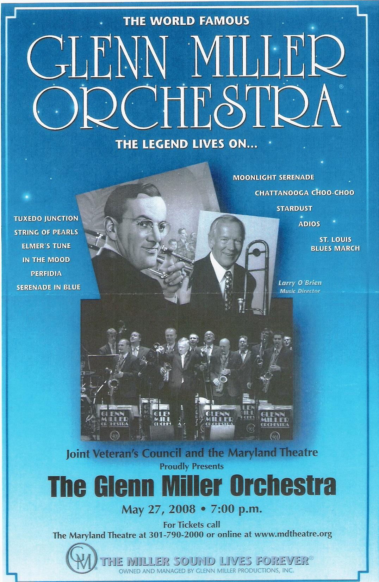
This Month’s information covers “VA’s Special Access to
Service Disabled Veterans: Veterans who are 50

The Hagerstown VA Outpatient Clinic is located at

[Type a quote from the document or the summary of an interesting
The Hagerstown VA Outpatient Clinic is located at the Hub Plaza on Eastern Blvd., Hagerstown. Hours of operation are Monday thru Friday; 8:00 AM until 4:00 PM., Phone 1-866-399-0117 or (301) 665-1462
And Finally: “ When you get to the end of your rope, tie a knot and hang on.” – Franklin D. Roosevelt

